C
Connor Campbell
Matriculation Number
1/12/2026
Chatbot Assessment

Code Snippets | Chatbot Interaction Images
 | 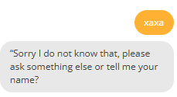
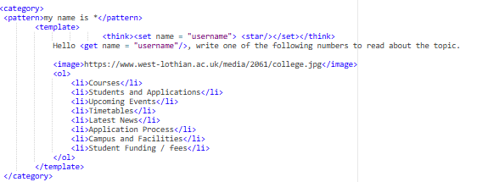 | 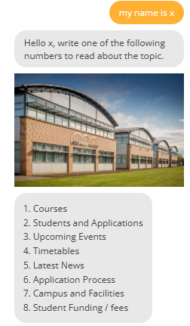
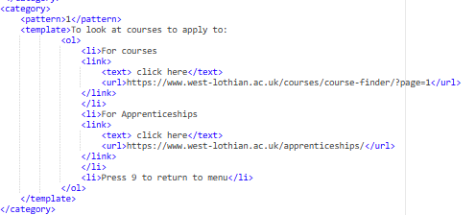 | 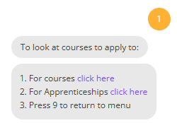
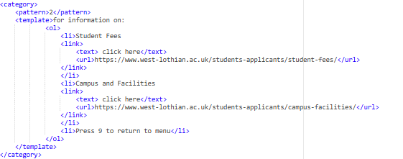 | 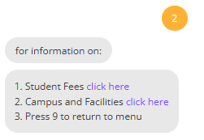
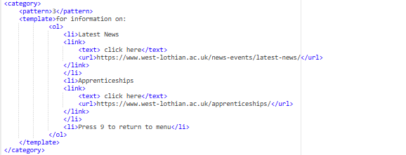 | 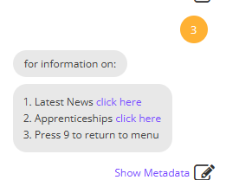
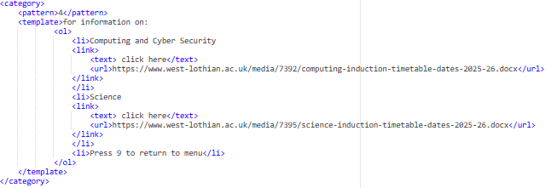 | 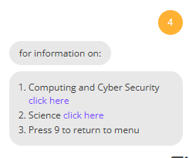
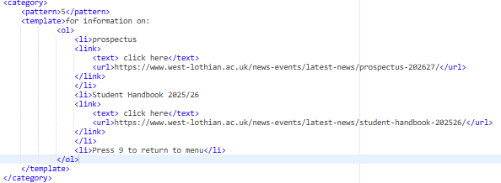 | 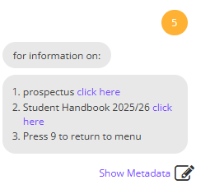
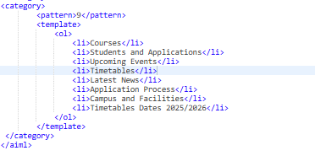 | 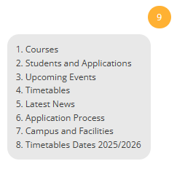

You must conclude this assessment with a 400 word report using the bulleted points below.

The applications of Chatbot’s in today’s society and their vocational fields.
Chatbots are key for users to gain access to information efficiently, with ease of accessibility and no need for an online chat team. The key things that a chatbot brings is 24/7 customer service allowing the users no need to wait for a human worker and fast response time which is important for businesses like online retail, banks and essential operations. Examples of these is checking banks’ balance, resetting passwords and providing links for help.
Some key examples of business where this is important are the following:
The healthcare system:
Having chatbots allows the ability to streamline patient information collecting reducing wait times on the phone and avoiding queuing systems. It also allows quicker booking of appointments and ordering of medications.
Online Retail:
Online retail bots are important for customer feedback, checking policy of the store and automating returns, it can also help with recommendations for example asking for “Red shoes in a size 5” could return entries of it.

The benefits of using Chatbot’s.

Benefits of using a chatbot is as said before are no need for a 24/7 team to keep up with client requests which in turn reduces operation costs, can be used to track customer influence of product to see trends and more.
Chatbots also have a benefit to accessibility for users with impairments like being mute, anxiety disorder and various other conditions. This overall is huge impact on society allowing better access to needs of users.

The techniques that you used to achieve the desired outcome to create a working Chatbot.
To create the final result, I used text recognition looking for user inputs and output a relevant result based on it, this allowed the user to get information quickly and effectively.
I also conducted rigorous testing checking to make sure my “Catch-all” procedure makes any not anticipated inputs get an error message that is informative and gives proper response. I also made sure all pages had a usable hyperlinked text to gain more access to information, using a “call code” to reshow the menu of choices and displayed a picture to for aesthetics.
More so I used the list function to properly display all choices with number corresponding to each choice as a easy to use menu which also displays the users name that is input on the first question of the bot before the main menu.

